Decision Tree Experiment Results

# Average Accuracy over Multiple Runs

|  |  |  |  |  |
| --- | --- | --- | --- | --- |
| Runs | Best Attribute (Information Gain) | Best Attribute (Gini Impurity) | Random Top 3 (Information Gain) | Random Top 3 (Gini Impurity) |
| 1.0 | 93.06 | 91.62 | 80.92 | 76.59 |
| 10.0 | 92.89 | 92.2 | 81.97 | 81.04 |
| 20.0 | 92.98 | 92.36 | 81.29 | 80.3 |
| 50.0 | 92.98 | 92.68 | 81.48 | 80.45 |

Accuracy Graph:

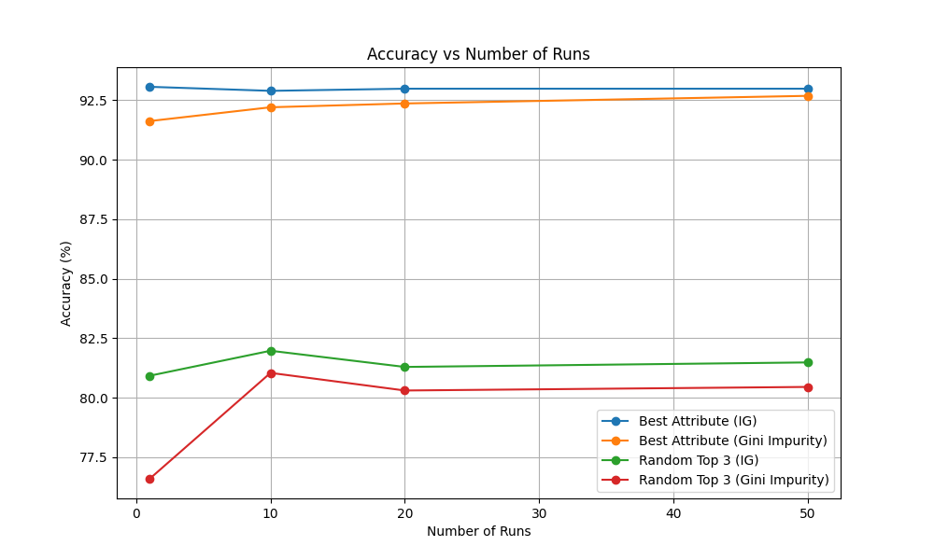

Explanation of Behavior:

The results show that always selecting the best attribute results in the highest accuracy, with Information Gain slightly outperforming Gini Impurity. As we increase the number of runs, the accuracy stabilizes, and the difference between the two selection strategies (IG vs Gini) becomes more pronounced.  
Randomly selecting from the top three attributes consistently leads to a drop in performance, indicating that choosing the most informative feature yields better classification accuracy.  
The stability of the performance increases with more runs, as expected.